User Support Project Outline

Submitted to: Prof. Anoop Saxena

Submitted by: TEAM-3

(Arshdeep Singh, Irwin Preet Kaur, Shreyas Dutt, Gursher Singh)

# Product Name

Lenovo Thinkpad Series

# About the product

The Lenovo ThinkPad is a preferred option, for multiple different environments due, to its durability and advanced features. It enables professionals to enhance their productivity across a range of business tasks.

# Environment Description

1. Office Settings; This is where the majority of Lenovo ThinkPad users seek assistance. Offices can vary greatly from businesses to corporations. Some offices may have ThinkPads while others may only have a few.

2. Educational Institutions; Lenovo ThinkPads are commonly used in schools, universities, and libraries. Students and teachers may require help with utilizing ThinkPads for purposes.

3. Healthcare Facilities; ThinkPads are also utilized in healthcare settings such as hospitals, clinics, and doctors' offices. Healthcare professionals may need support in utilizing ThinkPads for care and administrative tasks.

4. Retail Locations; Lenovo ThinkPads can be found in stores like electronics shops, office supply stores, and specialized computer stores. Retail employees may need to assist customers purchasing ThinkPads or addressing issues with their devices.

5. Manufacturing Sites; Lenovo ThinkPads are manufactured in factories where workers might require assistance with identifying and resolving issues, on the assembly line or repairing devices.

The user support project aims to provide assistance and ensure operations within these environments.

# Types of user support being provided by Lenovo ThinkPad

* User Manuals and Documentation: Each Lenovo ThinkPad laptop includes detailed user guides and manuals that contain technical specifications, maintenance instructions, and troubleshooting tips.
* Lenovo Vantage Software: Lenovo Vantage is pre-installed system management software that allows users to monitor system health, optimize performance, and easily access Lenovo's support resources.
* Comprehensive User Support Resources: Lenovo provides a broad online knowledge base with technical articles and FAQs, real-time chat and email support for direct assistance, and self-service resources such as repair guides and DIY tutorials, available to IT professionals and enabling independent problem resolution.
* *Warranty Services*: Lenovo ThinkPad provides complete standard and extended warranty plans that cover hardware issues and defects.

# Potential problems/issues faced by users

* Vulnerabilities in security: Unpatched software or firmware can expose sensitive data to cyber threats and harm system integrity.
* Obstacles in performance: Resource-concentrated applications can cause problems in performance, slowing down critical tasks.
* Outdated or corrupt BIOS/firmware can cause system instability, safety risks, and hardware failures.

# Problem-solving strategies

*Security flaws:*

Immediately update the operating system and software with security patches. Use reliable antivirus and antimalware programs.

*Performance barriers:*

For better performance, increase the RAM or storage capacity of the hardware. Enhance the system's startup and background operations. Utilize performance analysis tools to spot resource-intensive applications.

*Issues With BIOS/Firmware:*

Update your BIOS and firmware frequently by visiting the manufacturer's official website. Keep copies of older firmware versions in backup for recovery. For assistance with urgent firmware problems, get in touch with manufacturer support.

# Flowchart

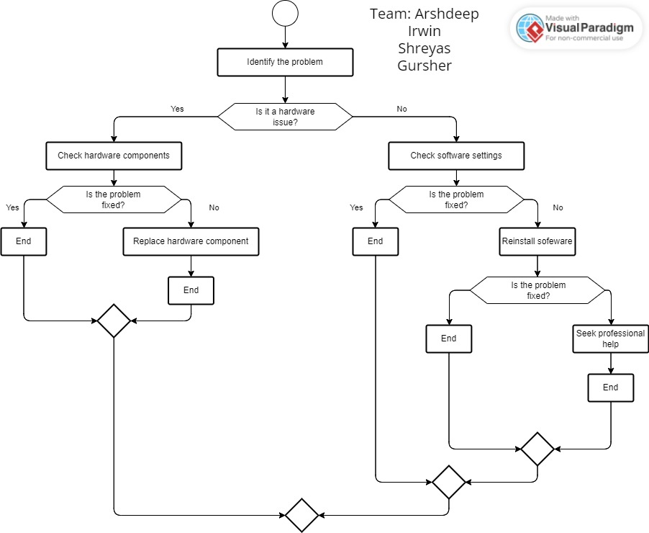

# Script Headings:

1. Checking the software settings
2. Checking and Replacing the hardware components
3. Reinstalling the software
4. Network Troubleshooting
5. Hardware Troubleshooting
6. Software Troubleshooting

# Checklists Headings:

1. Network Troubleshooting Checklist
2. Hardware Troubleshooting Checklist
3. Software Troubleshooting Checklist

# Script for Software Troubleshooting

1. Make sure that the software is installed properly by checking its installation status.

If you're unsure, about how to install it refer to the software documentation. Contact the software vendor for assistance.

2. Keep your software up to date by checking for updates.

Many software providers release updates frequently to address issues and introduce features.

You can check for updates on the software vendor's website or by using the built-in update feature of the software.

3. Confirm that the software is compatible with your operating system and hardware.

Refer to the documentation of the software or visit the website of the vendor to verify its compatibility with your system.

4. Ensure that there are no conflicts between the software and any other applications installed on your computer.

You can try disabling programs to see if it resolve any issues you might be experiencing.

5. Double-check that you have configured the software correctly according to your requirements.

If you need guidance on how to configure it refer to its documentation. Reach out to the vendor, for expert support.

6. Restarting your computer can sometimes resolve issues easily.

# Escalation arrangement

Level 1 – Technical Support

* Begin with a customer inquiry to grasp information regarding the problem.
* Engage with customers to gather essential issue details.
* Apply basic troubleshooting using pre-existing solutions in the system.
* Escalate unresolved issues to Level 2 support.

Level 2 - Technical Support Specialist

* Conduct thorough technical analysis for efficient problem-solving.
* Use specialized tools and knowledge for advanced diagnostics.
* Develop and implement solutions to resolve complex issues.
* Escalate persistent problems to Level 3 support.

Level 3 - Manufacturer Support

* Manufacturer's tech support for resolving the issue.
* Gather and provide relevant information to the manufacturer to facilitate troubleshooting and resolution.
* Coordinate necessary hardware repairs or replacements.

Level 4 – Engineering Support

* Provide high-level technical support for complex issues.
* Conduct root cause analysis to identify the fundamental causes of the issue.
* Implement long-term solutions to prevent problem recurrence.

Additional Procedures

Detailed Case Documentation:

* Maintain thorough case records to track progress and facilitate learning.
* Log issues in a centralized knowledge base for efficient future escalations to enhance customer experience.

# Tools to support/enhance the user experience

* Ensure that customers can easily get in touch with support. Make sure to provide straightforward contact details on your website and, in the product documentation.
* A ticketing system is a software tool that assists in managing customer support tickets. It enables the tracking of tickets assigning them to agents and setting priorities. A designed ticketing system should be user-friendly, for both customers and agents. By implementing a ticketing system you can effectively. Handle customer support tickets ensuring that all issues are promptly and efficiently addressed.
* Gathering feedback, from customers through customer satisfaction surveys is another practice. This feedback allows you to pinpoint areas where you can enhance the user support experience.
* Make sure to check in with customers after resolving their issues. This demonstrates that you genuinely value their satisfaction and are dedicated to delivering the user support experience.
* Lenovo Diagnostics: Lenovo offers diagnostic tools that may be used to locate and fix hardware-related problems. These resources are available on the Lenovo support website for your individual ThinkPad model or in the Lenovo Vantage software.
* Windows Troubleshooters-Windows comes with built-in troubleshooters for several issues, such as issues with hardware and devices, network issues, and system performance. You may locate them by typing "Troubleshoot" into the Windows search bar.
* Malware Scanners: To make sure your ThinkPad is clear of infestations that might impair performance, conduct a complete malware scan using trusted antivirus and anti-malware software.
* Disc Cleanup: To clear out any unwanted debris that could be eating up space on your hard disc, use the Disc Cleanup application that is integrated into Windows.